Empire Health System

Mass Casualty Incident (MCI)
Disaster Triage Annex
(Without Hazardous Material/Bioterrorism Exposure)

[Date ], 2014

To activate this plan:
- NOTIFY HOSPITAL OPERATOR (DIAL ###)
- State: “THIS IS A CODE HICS/CODE TRIAGE ALERT”
- DESCRIBE LOCATION, SITUATION AND ASSISTANCE NEEDED

Approved By: ___________________________
, CEO

__________________________
, Director of Patient Care Services

___________________________
, Nurse Manager ED

Table of Contents

Introduction 3
Scope 3
Assumptions 3
Concept of Operations 4
1. Initial Information…………………………………………………………………………………4
2. Incident Response 4
A. MCI with No Notice 4
B. MCI with Prior Notification 5
Senior Administrator or Nursing Supervisor Actions 5
Emergency Department Actions for this Annex:
➢PREPARING FOR PATIENT ARRIVAL 6
Table 1. Expanded Treatment Areas 6
Table 2. Supply Delivery 7
Table 3. Staffing Reassignment…………………………………………..…………………….7
➢PATIENTS HAVE ARRIVED IN THE HOSPITAL 8
Patient Triage……………………………………………..…………………………….…………8
Treatment Areas 8
Expectant/ DOA Area… ………….……………………….…………………..………………..8
ED Charge Nurse…………….………………………………….…………..……………………9
ED Unit Clerk…………………………………………..………………………………………….9
3. Communications………………………………………………….………………………………9
4. Reporting Personnel………………………….…………………………………………………10
5. Psychosocial Considerations..………………………………….………………………………10
6. Security……………………………………………………………………………………………10
7. Hospital Surge Capacity..….…….………………………………………………………………10
8. Patient Tracking..…………………………………………………………………………………10
9. Annex Maintenance and Evaluation….………………………………………………………..10

Department Plans:
A: Security Actions
Table 4. Radio Distribution and Channels 11
B: Surgery Department Actions 12
C: Radiology Department Actions 13
D: Laboratory Department Actions……………………………………………………………14
E: Hospital Command Center Actions………………………………….…………….………15
:
ATTACHMENTS
ATTACHMENT A- Adult and Pediatric Triage/ ED Patient Flow……………………………...17
ATTACHMENT B- SMART Triage Tags…………………………………………………………18
ATTACHMENT C- SMART Triage System….. .......19
ATTACHMENT D- JumpSTART Triage System ..…………………………………………..….20
ATTACHMENT E- Immediate Treatment Area.………………………………...……………….21
ATTACHMENT F- 2nd Priority- Delayed Area………………..….………………………………22
ATTACHMENT G- 3RD Priority- Minor Area………………..….……………….………………23
ATTACHMENT H- Deceased or Expectant Area…....………………………………………….24
ATTACHMENT I- JumpSTART Pediatric Triage ..…………………………………………..….25
ATTACHMENT J- Triage Tag Patient Details………………………………...………………....27
ATTACHMENT K- Triage Tag Glasgow Coma Scale……………………..……………………28
ATTACHMENT L- Triage Tag Patient Assessment & Treatment…………..……….…………29
ATTACHMENT M-Contaminated Victim Triage Tag….….. ..….…........…...30

Introduction

The purpose of this Annex is to provide direction for an effective, coordinated response to both a community mass casualty emergency or to an internal emergency impacting Empire Healthcare System

The Annex is developed to manage an incident where the number of patients expected in the Emergency Department (ED) overwhelms normal capacity, including the “worried well”, with the intent of treating up to a 20 percent increase above the average daily ED census in patients in a 24 hour period.

The Annex identifies responsibilities of individuals and departments in the event of a disaster situation, and identifies emergency preparedness activities and responses.

This Annex refers to but does not include the response to external hazardous materials or bioterrorism/weapons of mass destruction agent with contaminated patients.

Scope

This Annex applies to an MCI event without contamination at the Empire Healthcare System and affiliated organizations. The Annex defines incident response actions for the ED, and key operational roles, areas, and departments. It refers to the Comprehensive Emergency Management Plan (CEMP) for the response actions performed by the Hospital Incident Command System (HICS) and Hospital Command Center (HCC) to manage the event response.

Assumptions

- Patients may arrive by ambulance Emergency Medical Service (EMS) or on their own (private vehicle). Little or no notice may be given to the hospital.

- A second wave of more serious EMS transported trauma victims should be considered when initially occupying operating rooms with patients requiring surgery.

- The CEMP Explosive Annex or Biologic Event Annex should be used for this type of mass casualty event.

- If contaminated victims are suspected or present, the hazardous materials Decontamination and Access Control Procedures should be activated. Key considerations:

  - The most contaminated victims or “worried well” will arrive on their own for a hazardous materials event. Contaminated victims should not be brought into the hospital until they have been decontaminated.

  - EMS should not be transporting contaminated victims to the hospital – always question if and how the patient has been decontaminated.

  - If a Nerve Agent exposure with multiple victims is indicated, request for Chempack activation should be considered and the Chempack Hub Hospital Annex activated.

Concept of Operations

This is implemented as an Annex to the Empire Healthcare System Comprehensive Emergency Management Plan (CEMP) using the Hospital Incident Command System (HICS).

Throughout this Annex, the actions of key roles and Departments may be described in two stages:
- PREPARING FOR PATIENT ARRIVAL
- PATIENTS HAVE ARRIVED AT THE HOSPITAL, AND THE HOSPITAL COMMAND CENTER (HCC) IS ACTIVATED

- Initial Information

Any employee who learns of an occurrence that might constitute an MCI disaster
should attempt to obtain the following information and immediately report to their supervisor:
- The name, agency, and contact information for the person reporting the incident.
- What was the occurrence?
- What is the location of the occurrence?
- How many casualties are estimated?
- What type of injuries?
- How many victims may the hospital expect, and when?
- If a hazardous materials contamination is possible.

- Incident Response
            - A. Incident Without Prior Notice

            - When a no-notice incident meeting the activation criteria is detected first in the ED, the Casualty Care Group Activation/Response as discussed in the Empire Healthcare System CEMP will be activated.
            - The ED Nurse in charge or Triage Nurse/ Casualty Care Group Supervisor shall:

- Determine if the ED immediate or imminent situation meets CEMP activation criteria, most likely due to:
- The unexpected arrival of multiple and/or contaminated casualties.
- An incident notification received in the ED from a public safety source indicating the impending arrival (within 15 minutes) of multiple patients from an incident,
- The outbreak of a disturbance, fire, or unusual situation in the ED.

- Assume Incident Command and direct the immediate activation of the Casualty Care Group. Appoint or assume Casualty Care Supervisor; and assign staff to assume the Triage Unit Leader, Immediate Treatment Unit Leader, Delayed Treatment Unit Leader, and Minor Treatment Unit Leader roles. Staff should configure the ED to manage the anticipated influx of patients or other unusual situation.

- If victims present as, or could be contaminated with hazardous materials ensure ED access is secured and activate the hospital’s Code Orange/ HazMat Decontamination Annex.

- Notify as soon as possible the Nursing Supervisor or Senior Administrator who shall assume the role of Incident Commander.

- Initiate Hospital Mobilization. The ED nurse in charge or Casualty Care Group Supervisor shall:
- Brief the Incident Commander/ Nursing Supervisor who will activate the CEMP and Hospital Command Center (HCC) based on conditions.
- Initiate the appropriate Code(s) and Level of Activation to the switchboard who will announce overhead.

B. Incident with Prior Notice. For disaster triage events with prior notification:

Senior Administrator or Nursing Supervisor Actions

- Assume initial Incident Command, and determine
- Need to initiate this Annex.
- If hazardous materials, Bioterrorism/ Weapons of Mass Destruction agents are involved, activate the Code Orange (Decontamination) Annex.
- If a nerve agent is suspected, activate the Chempack Annex.
- If an Explosive incident, initiate the Explosive Annex.

- Before patients arrive, contact the Switchboard and have them announce:
[insert your hospital’s codes/ levels]
- CODE TRIAGE, HICS LEVEL 1, EMERGENCY DEPARTMENT
- (ADD CODE ORANGE IF DECONTAMINATION REQUIRED)

- Implement CEMP, HICS, HCC at the appropriate level. Other Annexes may be activated as determined by HICS, including the Decompression Annex (rapid patient discharge process) and Bed Surge Annex.

- Notify Hospital Staff per the CEMP: [specify groups]
- Administrative group
- Command group
- Medical Staff
- Units and Departments who will initiate staff call down as directed

- Notify the following and provide information on the type of injuries expected.
Consider when notifying departments if their services must be relocated or cancelled (ambulatory surgery, PACU, other) to activate a Treatment area, or manage priority patients.
- Surgery Department
- Radiology Department
- Laboratory
- ED Medical Director
- ED Nursing Director
- Chief of Surgery
- Chief of Anesthesia
- Surgery Nursing Director
- On-Call Medical Staff Specialists (as needed)
- Disaster Mental Health Team
- Local Law Enforcement for security if decontamination required or as indicated

- Activate and ensure Expanded Treatment Areas are prepared with staff, supplies, and equipment. See Table 1.0 Page 6.
- Assure Clinical, Registration, and runner staff have been assigned to Triage and Treatment Areas, have been provided a communications device, and assigned channels (for radio).
  - Assure physicians are assigned to Treatment areas as soon as available.
- Confirm staff and supplies from other departments are being re-assigned per the HCC/ HICS.

- Establish radio/ or other communications with the HCC, ED, Triage, Expanded Treatment areas, and Security staff.

- Brief the incoming Incident Commander when transferring Command.

Emergency Department Actions

PREPARING FOR PATIENT ARRIVAL:

- Establish radio/ other communications with the HCC/ HICS, Triage, and Expanded Treatment Areas.

- Request additional staff and resources as needed from the HCC/HICS.

- Assess the current ED census and initiate appropriate decompression of all non-critical patients through discharge, admission to inpatient units, or transfer to expanded treatment areas when activated.

- Assure ED access is controlled and all arriving ED patients are directed to one location or [specify locations for ambulatory and ambulance entrance Patient Reception and Triage].

- Obtain supplies from (location)
- Triage Tags (Attachments D,H,I, and J)
- Emergency Medical Record and Disaster Patient Log (describe- paper or electronic, i.e., trauma tracker, Pisces)
- HICS vests
- Other, specify

- Provide just-in-time training for Disaster Triage as needed. See Attachments F-K.

- Mark Designated Treatment Areas (using [specify, i.e., color Flags]
- Triage
- Immediate Treatment (Red Area)
- Delayed Treatment (Yellow Area)
- Minor Treatment (Green Area)
- DOA or Terminal (Black Area)

- Prepare Expanded Treatment Areas as directed with staff, supplies, and equipment.
- Clinical, Registration, and runner staff are assigned to Triage and Treatment Areas
- Provide communications devices, and assign radio channels.
- Physicians are assigned to Treatment areas as soon as available.

- Confirm receipt of supplies/equipment: See Table 2, Supply Delivery p.7

- Monitor Medical Emergency Radio System (MERS) regarding arriving patients

Table 1. Expanded Treatment Area Locations [Personalize to hospital locations]
Expanded Treatment Area | Primary Location | Alternate Location
Triage | Ambulance Bay
Immediate Treatment (Red Area) | ED
Delayed Treatment (Yellow Area) | ASU
Minor Treatment (Green Area) | Physical Therapy
DOA or Terminal (Black Area) | Morgue

Table 2. Supply Delivery [Personalize to hospital locations]
Item | Quantity | Source | Assigned
Ambu bag | 4 | Respiratory Therapy | Emergency Department
Breathing masks | 4 | Respiratory Therapy | Emergency Department
Carts | 6 | 2nd Floor | Emergency Department
Code Cart | 1 | Heart Center | Emergency Department
Portable O2 Cylinder | 6 | Respiratory Therapy | Emergency Department
Wheel chairs | 6 | Lobby | Emergency Department
Stretchers | 6 | ? | Emergency Department
EKG machine | 1 | Respiratory Therapy | Operating Room
Automatic Blood Pressure Machine | 3 | ASU/2nd Floor/OR | Emergency Department
Glidescope | 1 | OR | Emergency Department
Difficult Airway Cart | 1 | OR | Emergency Department
Minor Treatment Supplies (description) | 1 Cart | ? | Minor Treatment Area
Isolation Cart  (if requested) | 1 | ? | Emergency Department
Chempack*  Requires Chempack Annex activation | Hospital partition(s) | Assigned Hub Hospital or location if hub | Emergency Department
Other:  Computer on Wheels for patient data entry |  |  | Triage and Treatment Areas
Disaster Charts |  |  | Triage Areas
HICS Vests |  |  | Emergency Department, Treatment Areas
Medications |  | Pharmacy

Table 3. Staffing Reassignments [Personalize]
Staff Type | Number | Source | Assignment
EKG Tech/  Respiratory Therapist | 1 | Respiratory Therapy | Emergency Department
Lab Tech | 1 | Lab | Emergency Department
Medical Records Clerk | 1 | * Medical Records | Emergency Department
PCA | 1 | 2nd Floor | Emergency Department
PCA | 1 | 2nd Floor | Emergency Department
RN | 1 | 2nd Floor | Emergency Department
RN | 1 | *Cardiac Rehab | Emergency Department
Unit Clerk | 1 | *Primary Care | Emergency Department
LPN | 1 | *Primary Care | Ambulatory Surgery Unit
NP | 1 | *Primary Care | Ambulatory Surgery Unit
Radiology Tech | 1 | Radiology | Operating Room
Lab Tech | 1 | Lab | Ambulatory Surgery Unit
Radiology MD | 2 | Radiology | Radiology
Radiology Tech | 2 | Radiology | Radiology
* IF THIS DEPARTMENT IS NOT OPEN AT THE TIME OF THE EMERGENCY, THE HCC SHOULD MAKE ALTERNATE ARRANGEMENTS FOR CALLING IN THE STAFF.

PATIENTS HAVE ARRIVED

  - Assign staff sent from other departments/ labor pool (located in the xxxxxxx) to areas as needed. See Table 3, Staffing Reassignment, p.7

  - Ambulance staff will unload patients and move them to the Triage Area.

  - Security/ assigned staff will direct patients arriving at the ambulatory entrance to the Triage Area(s).

  - All patients will be logged in to the electronic registration system or on the paper form as they arrive at Triage.

Patient Triage

- Perform initial examination and classify the patient’s treatment level, affix Triage Tag.
- Patients arriving with triage tags from the field are re-triaged on arrival.
- This area is for classification of injured. No treatment will be given in this area.
  - All current and arriving patients to the ED are triaged using the same criteria.

- Log patient and assigned destination into electronic system/ or on paper Log.

- Start Emergency Medical Record (disaster chart).

- Direct the ambulance staff to the appropriate treatment area.

- Maintain contact with the HCC, ED, and Treatment Areas as directed/ needed; request resources as needed from the HCC/HICS. .

Treatment Areas

- Transfer patients to carts, wheelchairs, etc. as soon as possible.

- Log patients in (electronic or paper system) as they arrive, and each movement should be documented. Registration is initiated as time and patient condition allows.

- Patients requiring immediate surgical intervention will be stabilized and then sent to the Surgical Area as prioritized.

- Follow standard treatment protocols whenever possible.

- Maintain contact with the HCC, ED, and other areas as directed/ needed; request resources as needed from the HCC/HICS.

- Remain in the Treatment Area assigned until relieved.

- Orders will be written on the Emergency Medical Record.

Expectant/ DOA Area

- Log patients in (electronic or paper system) as they arrive, and each movement should be documented.

- Confirm the triage diagnosis.

- Make terminal patients as comfortable as possible.

- Assign Disaster Mental Health Team/ spiritual care staff to expectant patients.

- Only authorized people are to be present.

- Maintain contact with the HCC, ED, and other areas as directed/ needed; request resources as needed from the HCC/HICS.

ED Charge Nurse

- Coordinate bed assignments and needs with the HCC.

- Monitor staffing and assign staff.

- Monitor supplies and equipment.

- Maintain contact with the HCC as directed/ needed, request resources as needed.

ED Unit Clerk

- Track patient disposition and or admission.

- Monitor MERS.

- Report status changes.

- Update the HCC as directed/ needed.

NOTE: IF TRANSFERS ARE PERFORMED, CONSIDER COBRA AND EMTALA ISSUES

- Communications

- All Department Heads or designees are responsible for calling in their own employees upon notification from the Nursing Supervisor, Incident Command Staff or designee.

- All incoming calls seeking patient information shall be referred to the HCC.

- Visitors, family and friends will be [describe- detained in the Main Lobby until permission has been granted to enter.]

- All calls from news media and official agencies shall be referred to the HCC or as designated by the IC.

- Reporting Personnel

- All employees should use the XXXXXXXXXXX door when reporting to the hospital.

- Active and courtesy staff physicians report to triage area in the xxxxxxxxxxx. Non-staff physicians volunteering under emergency provisions of bylaws report to the xxxxxxxxxxx for identity verification before reporting to the Emergency Room.

- Staff reporting in will sign in at the switchboard before going to their department or designated location or to receive instructions from the HCC.

- On-site Nursing Service personnel remain at assigned floor and stand by for orders unless otherwise notified.

- Visitors should xxxxxxxxxxxxxxxxxxxxxxxxxxx.

- Elevators are used for EMERGENCY ONLY. Personnel shall use the stairways.

- Psychosocial Considerations

Empire Healthcare System has trained personnel who are part of our Mental Health/Spiritual Care Disaster Response Team. These staff will be focused not only on the families of the sick and dying but also on the staff who are caring for those patients. Activation of the team will be through the HICS/ HCC. A Family Assistance Center may be activated if needed by the HCC to support victims’ families.

- Security

Security is a very important element of the Mass Casualty Annex (see Attachment A.) Currently, security is provided by Empire Healthcare System staff (specify security or other) and local law enforcement agencies. Should a Mass Casualty event occur that affects our facility additional security measures will be put into effect.

- Hospital Surge Capacity

Increasing the number of hospital beds available for victims to be admitted will be coordinated by the HCC. The Hospitalist/ Bed Management Committee will coordinate patient discharges and victim admissions with the hospital medical staff and HCC per the Decompression Annex. The HICS/ HCC may cancel elective procedures and clinics to free up OR space, staff, and treatment area spaces, and activate additional areas as described in the Bed Surge Annex.

- Patient Tracking

Empire Healthcare System will initiate patient tracking processes upon patient arrival by logging patients into the electronic system. A computer on wheels will be brought to the Triage area. [Describe data to be entered]. If the electronic system is unavailable, a paper log of patients will be initiated (i.e., HICS 254 form.) Disaster patients will be tracked through electronic systems or paper by the HCC from Triage to Treatment areas, to diagnostic services, OR, and to final disposition. Patient information will be shared with the Family Assistance Center if activated.

- Annex Training, Maintenance, and Evaluation

- Training & Exercise Program. Training will be provided to staff on an annual basis that details the procedures that Empire Healthcare System will follow in the wake of a Mass Casualty event. Additionally, we will participate in local and regional exercises being conducted by our preparedness partners, including the Empire County Health Department, the Empire County Office of Emergency Management, NYSDOH, and others to test all of our Annexes. This will be done in accordance with procedures documented in the Empire County CEMP, the Empire Healthcare System CEMP, and Joint Commission/AOA/DNV requirements which say that healthcare facilities develop and exercise their Emergency Operations Annex (EOP) at least twice per year and that they update their EOP in accordance with After Action Report Improvement Annexs as applicable. Just-in-time training will be provided at the incident onset and throughout the response as needed.

- Revision Process. This Annex will be reviewed [at least once per year], or as indicated, to reflect required updates in accordance with procedures documented in the county CEMP and accrediting agency requirements or standards. Annex updates will include information learned from exercises and drills.
A. Security Actions

PREPARING FOR PATIENT ARRIVAL:

- Lockdown the hospital immediately if this is a contaminated victim event.

- Control access to the ED and direct walk-in patients to the established Triage point.

- Request Local Law Enforcement officer to the ED.

- Distribute radios per Table 4, assign communications channels.

- Maintain contact with the HCC as directed/ needed.

Table 4. Radio Distribution- use channel (specify)

Area | Channel
Hospital Command Center (located) TURBO RADIO
ED Nurses Station
Triage (Ambulance Bay )
Immediate Treatment (Red Area) ED
Delayed Treatment (Yellow Area) (Ambulatory Surgery)
Minor Treatment (Green Area) (Cafeteria)
Surgery
Radiology
Other- Family Assistance Center

PATIENTS HAVE ARRIVED:

- Coordinate response with local law enforcement

- Confirm communications channels and reporting intervals

- Direct family visitors to designated areas per the CEMP/ HCC.

- Surgery Department Actions

PREPARING FOR PATIENT ARRIVAL:

- Evaluate ability to treat patients

- Call-in additional Surgeons and staff

- Prepare Surgical Areas
- Complete current surgeries and consider not starting elective surgeries
- Designate a Surgical Holding Area

PATIENTS HAVE ARRIVED:

- Prioritize more Immediate patients

- As requested, send Surgeons to the Treatment Areas

- Record in the Emergency Medical Record

- Monitor supplies and equipment and request additional supplies as needed

- Maintain contact with the HCC, treatment areas, and ancillary departments as directed/ needed

- Radiology Department Actions

PREPARING FOR PATIENT ARRIVAL:

- Deliver supplies and equipment to assigned areas

- Assign or call in staff to be reassigned

- Evaluate ability to treat patients

- Prepare Radiology Areas
- Complete current procedures and consider not starting elective procedures

- Designate a Radiology Holding Area

PATIENTS HAVE ARRIVED:

- Send staff to re-assigned areas

- Prioritize more Immediate patients

- Immediately read Radiology films

- Record in the Emergency Medical Record

- Monitor supplies and equipment and request additional supplies as needed

- Maintain contact with the HCC, treatment areas, and ancillary departments as directed/ needed

- Laboratory Actions

PREPARING FOR PATIENT ARRIVAL:

- Deliver supplies and equipment to assigned areas

- Assign or call in staff to be reassigned

- Evaluate and report blood supply to the HCC

- Evaluate ability to perform stat and routine lab orders, prioritize services as directed
- Complete current procedures and consider not starting routine procedures

PATIENTS HAVE ARRIVED:

- Send staff to re-assigned areas

- Prioritize more Immediate patients

- Immediately perform stat orders

- Record in the Emergency Medical Record

- Monitor supplies and equipment and request additional supplies as needed

- Monitor/ report blood supply and maintain as needed

- Maintain contact with the HCC, treatment areas, and ancillary departments as directed/ needed

- Hospital Command Center Actions
        - 2 Hours

COMMAND
(Incident Commander):
- Receive hand-off briefing from initial Incident Commander
- Activate Hospital Command Center location, Command Staff and Section Chiefs, as appropriate
- Activate the Medical/Technical Specialists: Hospital Administration, Clinic Administration, Medical Staff and Pediatric Care
- Establish the operational period, incident objectives, and initial Incident Action Plan
- Establish communications with key hospital operational areas, including Triage and Treatment areas, Labor Pool, Departments, and Family Assistance Center. Gather status information and resource requirements:
- Number and types of casualties
- Number and location of treatment areas activated or under consideration
- Hospital status/problems; Staffing status/problems; Security status/problems; Transportation status/problems for mass casualty response
- Equipment/supplies status/problems
- Public information status
- Special needs populations status/problems
- Initiate call-back procedures for medical and non-medical staff as needed; establish Labor Pool and Medical Staff Area.

(PIO):
- Provide information to hospital staff, visitors, and families regarding situation status and hospital measures per demand.
- Activate the media staging area and provide regular briefings and updates.
- Participate in a Joint Information Center (JIC) if activated and coordinate with other agencies’ PIOs.
- Correct/ revise/ update information to be included in public information messages.
(Liaison Officer):
- Establish communications with the jurisdiction command, exchange situation status and critical issues/needs.
- Coordinate with Health Officers and Medical Health Operations Area Coordinator (MHOAC) for mass casualty operations:
- Is there a need to transfer patients to facilities treating similar illnesses/conditions?
- Can the MHOAC assist in identifying alternate care sites?
- Contact NYSDOH Regional Office for potential need to alter staff/patient ratio’s, as necessary
- Communicate with the jurisdiction EOC and Healthcare Emergency Preparedness Coalition (HEPC) for local, regional and state bed availability; and other health facilities situation status, surge capacity and capability, and bed availability.
- Communicate external resource requests for needed equipment, supplies, medications, personnel, etc.
- Request needed medical resources from System hospitals and vendors.
- If System and vendor resources are exhausted, request from WNY Hospital Mutual Aid Plan.
- If WNY Hospital MAP is unable to meet the need for medical resources, forward the request to the jurisdiction EOC as directed. The jurisdiction EOC will track progress of resources and provide updates to the HCC and Regional HEPC.
(Safety Officer):
- Ensure safety practices are being used
- Ensure that non-traditional areas used for patient care and other services are safe and hazard-free
OPERATIONS
- Activate Branch Directors and Unit Leaders and brief on the current situation
- Activate the hospital’s surge capacity plan
- Activate the Facility’s Disaster Mental Health Team
- Activate alternate care and sites as appropriate, including the Family staging and Assistance Center.
- Review all surgeries and outpatient appointments and procedures for cancellation and/or rescheduling
- Identify inpatients for early discharge or transfer to other facilities and direct staff to expedite discharges
- Establish a discharge area to free beds until patient can be transported
- Assess current staffing and project staffing needs/shortages for the next operational period and 24–48 hours out
- Ensure the rapid cleaning and turn-over of patient care beds and areas to expedite discharge and admission
- Ensure the use of appropriate personal protective equipment by staff and volunteers
- Consider extending outpatient hours to accommodate additional patient visits
Planning
- With the IC, establish operational periods, incident objectives and develop Incident Action Plan
- Institute patient, bed, personnel and materiel tracking and project needs for the next 24-48 hours
- Monitor information on disaster patients received and current hospital location.
LOGISTICS
- Anticipate an increased need for supplies, equipment, medications and personnel. Coordinate with Liaison Officer to request resources as appropriate
- Ensure the operations of communication systems and IT/IS
- Assist the Operations Section with the establishment of treatment areas and alternate care sites
- Manage solicited and unsolicited volunteers

ATTACHMENT A

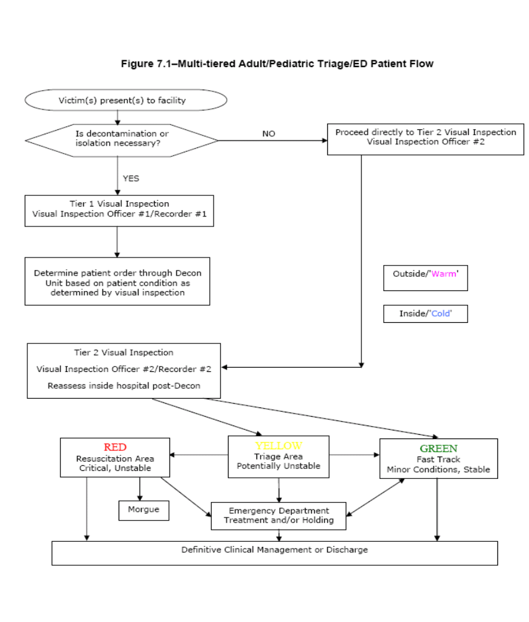

ATTACHMENT B- SMART Triage Tags

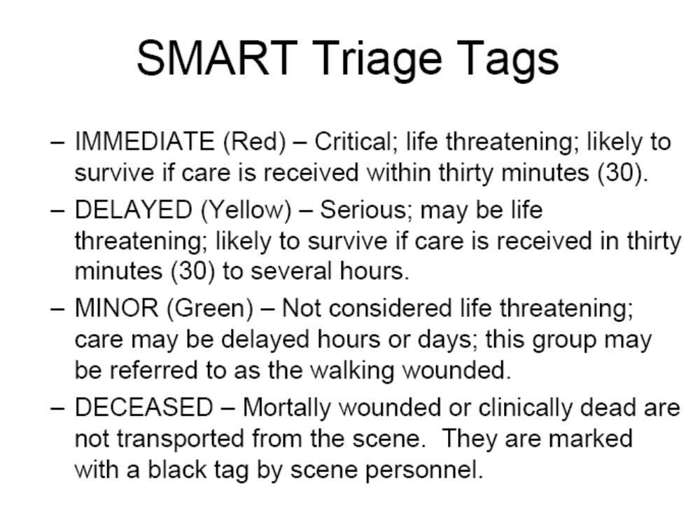
ATTACHMENT C

SMART/JUMP START Triage System

    - Both Smart and Jump Start Triage Systems are used for primary triage and utilize the ideologies of Simple Triage and Rapid Treatment.
    - It is the Gold standard for field adult multiple casualty (MCI) triage in the US and numerous other countries around the world.
    - It utilizes the standard four-triage categories.

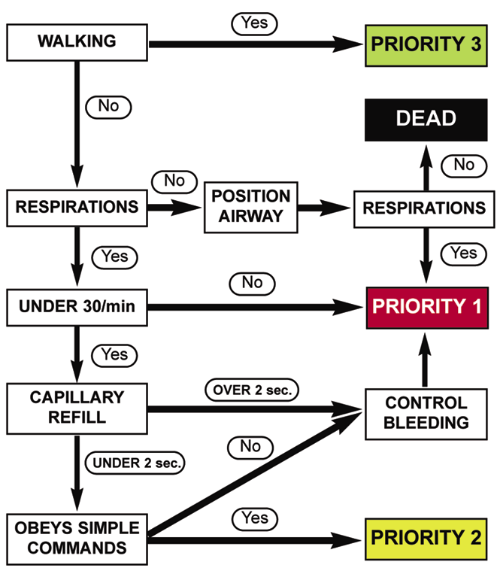

ATTACHMENT D
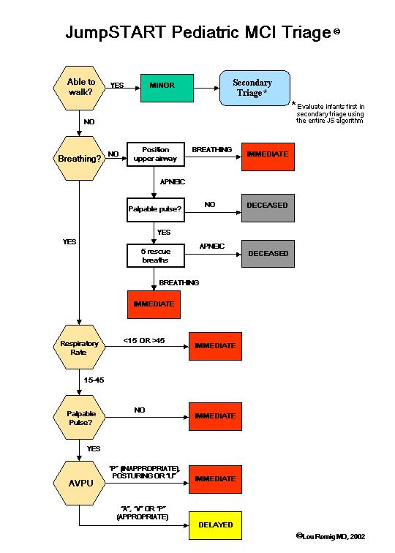

ATTACHMENT E
First Priority (RED) Immediate Treatment Area
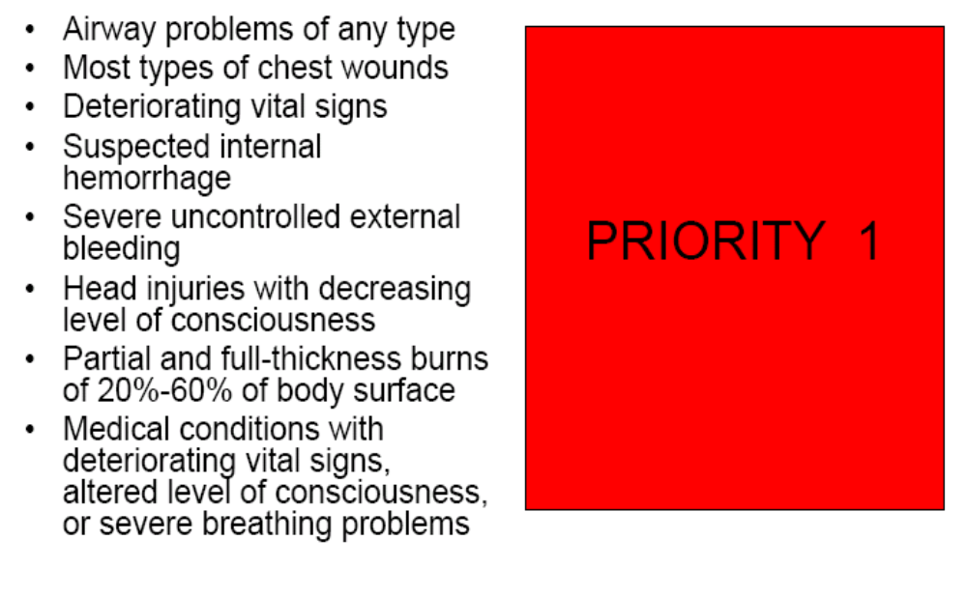
ATTACHMENT F
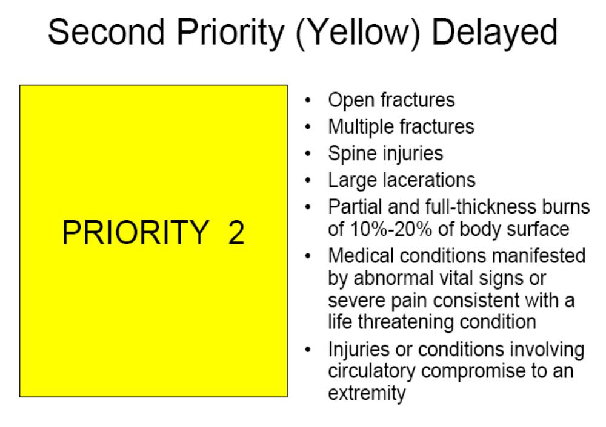

ATTACHMENT G
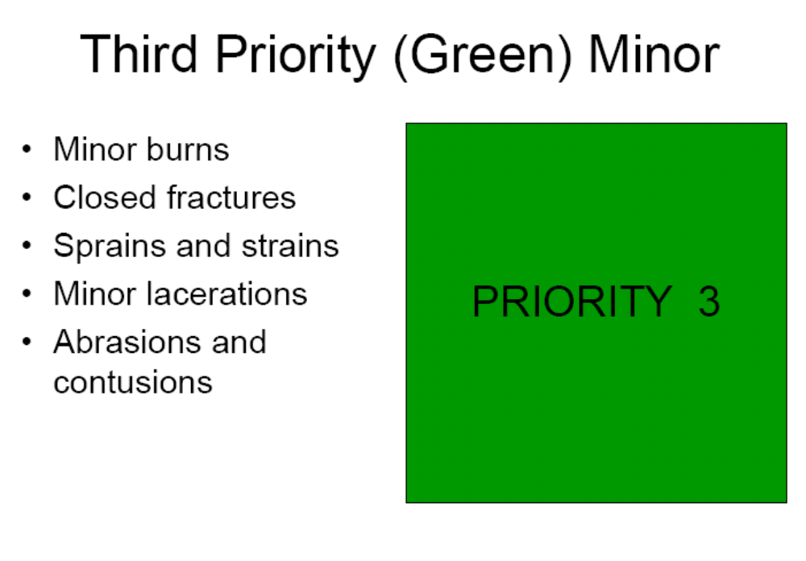
ATTACHMENT H

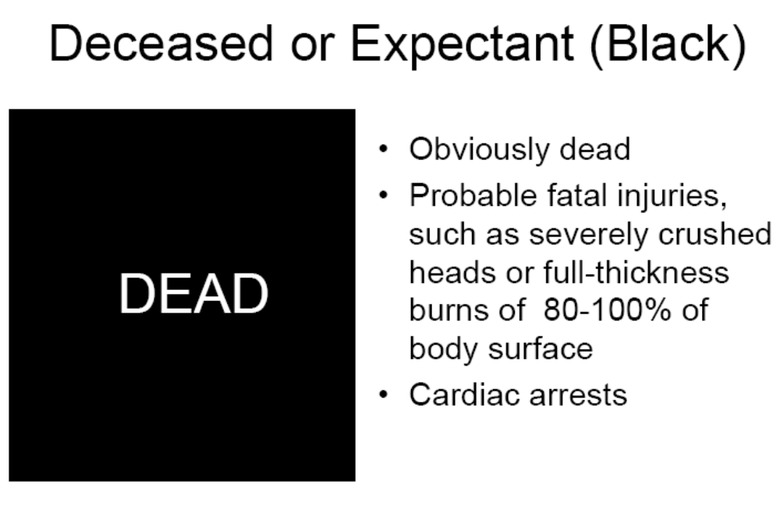

ATTACHMENT I

JumpSTART Pediatric Triage

- The over prioritizing of children will take valuable resources away from more seriously injured adults.
- Triage systems based on adult physiology will not provide accurate triage.
- The physiology of adults and children are not the same.
- Primary MCI triage is based on physiology.
  - START: Potential Problems with Children
- An apneic child is more likely to have a primary respiratory problem than an adult.
- Perfusion may be maintained for a short time and the child may be salvageable.
- RR +/- 30 may either over-triage or under-triage a child, depending on age.
- Capillary refill may not adequately reflect peripheral hemodynamic status in a cool environment.
- Obeying commands may not be an appropriate gauge of mental status for younger children.
  - JumpSTART: Age
- Initially ages 1-8 years chosen.
- Less than one year of age is less likely to be ambulatory.
- The pertinent pediatric physiology (specifically the airway) approaches that of adults by approximately eight years of age.
- The ages of “tweens and teens” can be hard to determine. The current recommendation is:
- If a victim appears to be a child, use JumpSTART.
- If a victim appears to a young adult, use START.
  - JumpSTART: Breathing
- If breathing spontaneously, go on to the next step, assessing respiratory rate.
- If apneic or with very irregular breathing, open the airway using standard positioning techniques.
- If positioning results in resumption of spontaneous respirations, tag the patient immediate and move on.
- If no breathing after airway opening, check for peripheral pulse. If no pulse, tag patient deceased/ non-salvageable and move on.
- If there is a peripheral pulse, give 5 mouth to barrier ventilations. If apnea persists, tag patient deceased/ non-salvageable and move on.
- If breathing resumes after the “jumpstart”, tag patient immediate and move on.
  - JumpSTART: Respiratory Rate
- If respiratory rate is 15-45/min, proceed to assess perfusion.
- If respiratory rate is <15 or >45/min or irregular, tag patient as immediate and move on.
  - JumpSTART: Perfusion
- If peripheral pulse is palpable, proceed to assess mental status.
- If no peripheral pulse is present (in the least injured limb), tag patient immediate and move on.
  - JumpSTART: Mental Status
- Use AVPU scale to assess mental status.
- If Alert, responsive to Verbal, or appropriately responsive to Pain, tag as delayed and move on.
- If inappropriately responsive to Pain or Unresponsive, tag as immediate and move on.
  - Modification for Non-ambulatory Children
- Infants who normally cannot walk yet.
- Children with developmental delay.
- Children with acute injuries preventing them from walking before the incident.
- Children with chronic disabilities.
- Evaluate using the JS Algorithm.
- If any RED criteria, tag as RED.
- If patient satisfies YELLOW criteria:
  - Yellow if significant external signs of injury are found (ie. Deep penetrating wounds, severe bleeding, severe burns, amputations, distended tender abdomen.)
  - GREEN if no significant external injury.
  - Note for Black Category Victims
- Unless clearly suffering from injuries incompatible with life, victims tagged in the BLACK category should be reassessed once critical interventions have been completed for RED and YELLOW patients.

ATTACHMENT J
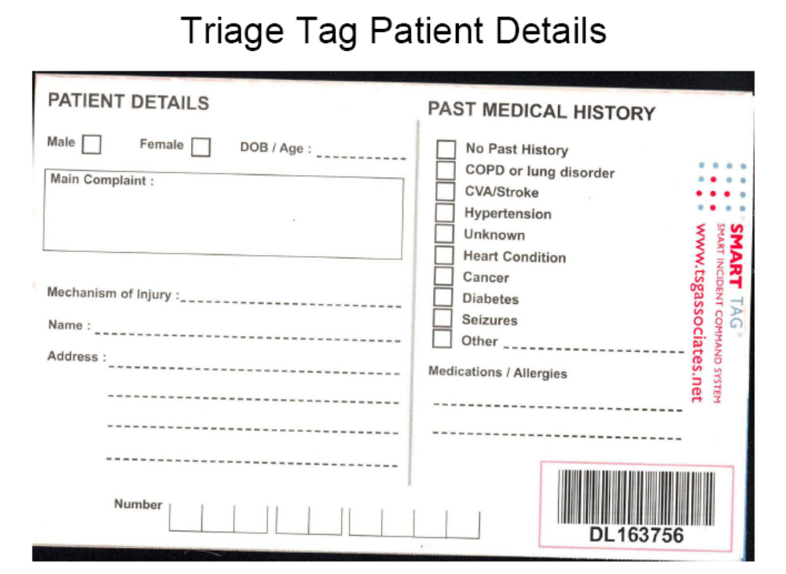

ATTACHMENT K
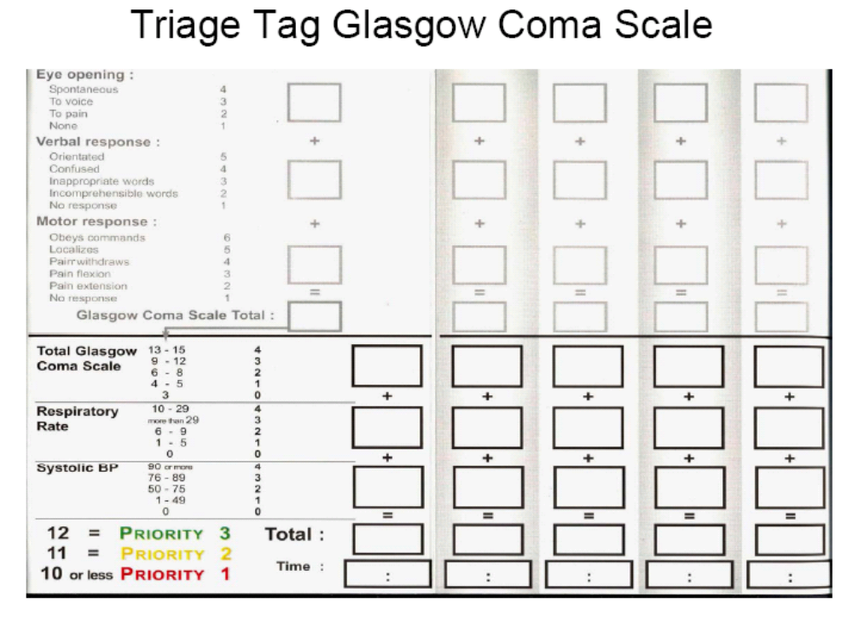
ATTACHMENT L
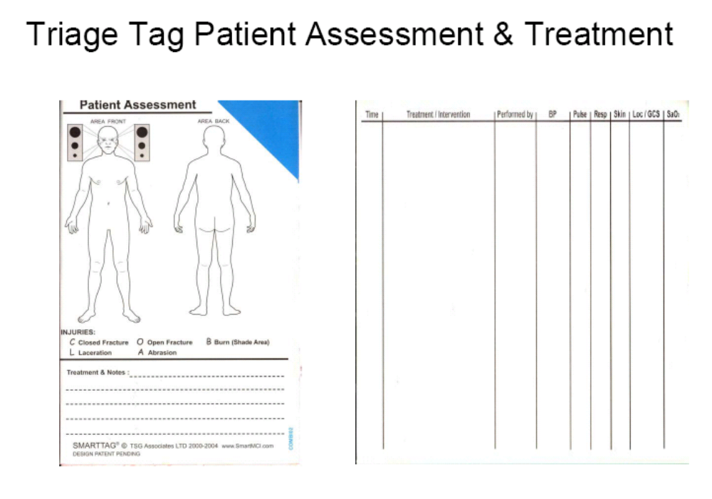

ATTACHMENT M-Contaminated Victim Triage Tag

Contaminated Victim Triage Tag
